#include <stdio.h>

int addition(int num1, int num2)

{

int sum;

sum = num1+num2;

return sum;

}

int main()

{

int var1, var2;

printf("Enter number 1: ");

scanf("%d",&var1);

printf("Enter number 2: ");

scanf("%d",&var2);

int res = addition(var1, var2);

printf ("Output: %d", res);

return 0;

}

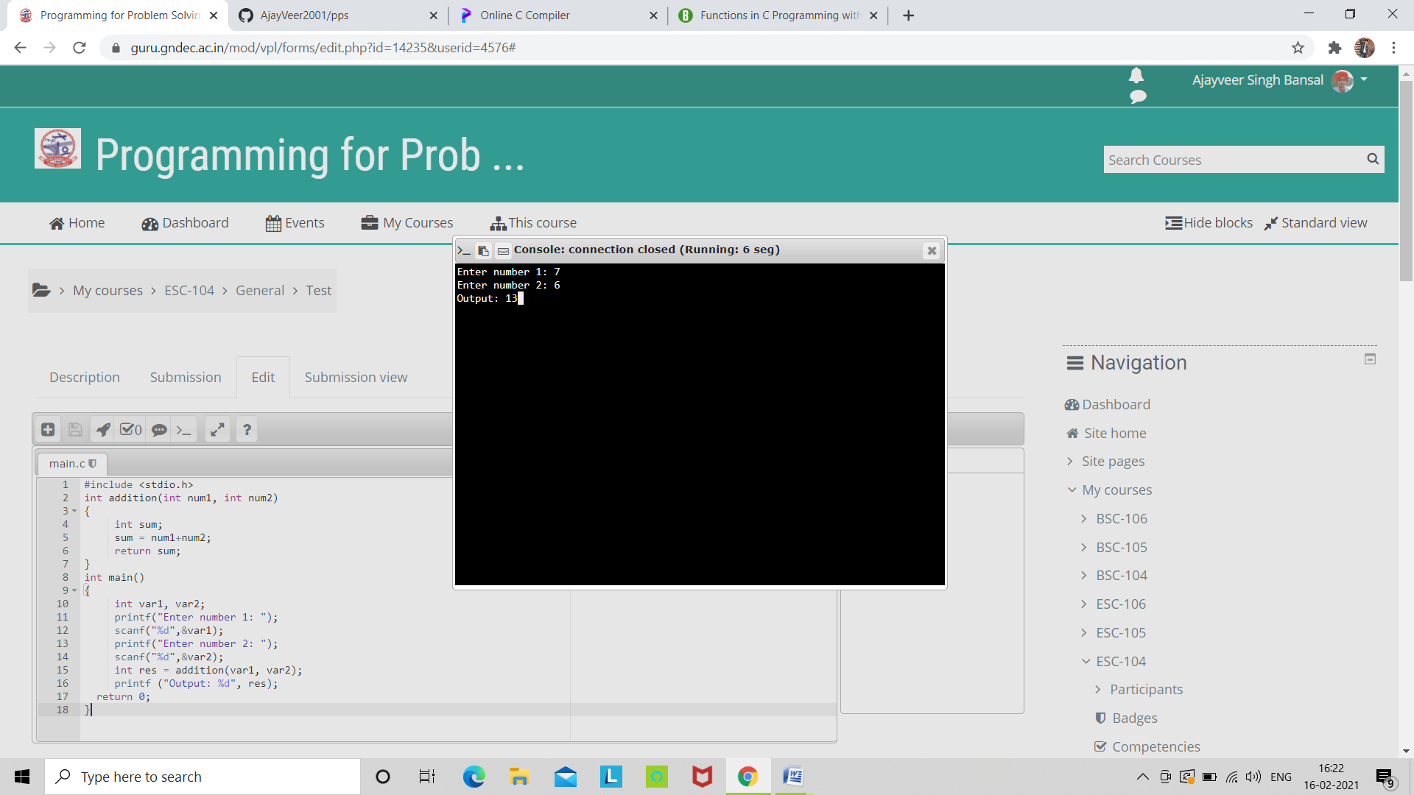

#include <stdio.h>

void introduction()

{

printf("Hi\n");

printf("My name is Ajayveer Singh Bansal\n");

printf("How are you?");

}

int main()

{

introduction();

return 0;

}

